Shivam Gautam

FGIPS

**Number guessing game**

Introduction :

This is a number guessing game. In this exciting and interactive python game , your goal is to guess the secret number chosen by the computer. The game will provide you with hints to guide you in your quest for the correct number.

Objective:

The main objective of the Number Guessing Game is to challenge and entertain players as they attempt to accurately guess a randomly selected secret number within a given range. This game aims to engage players in a fun and interactive experience that hones their logical thinking and decision-making skills. Participants will need to utilize deductive reasoning, adjust their strategy based on feedback, and persistently refine their guesses until they successfully uncover the hidden number. The game encourages an enjoyable exploration of numerical patterns and reinforces a sense of achievement when players correctly identify the secret number. Whether played individually or in a group, the Number Guessing Game provides an entertaining way to exercise cognitive abilities while fostering a spirit of friendly competition.

Background:

Immerse yourself in the world of the Number guessing game, where the intrigue of numerical mysteries meets the thrill of unpredictability. In this digital realm , players navigate the challenge of uncovering a secret number within a specified range, blending classic guessing game with the excitement of randomness.

Hardware and software requirement

Hardware requirement :

* Computer : Any standard computer or laptop with a modern processor.
* Input device: A keyboard for entering guesses.

Software requirements

* Operating system: the game is compatible with windows, macOS , and Linux.
* Python interpreter: Ensure that python in installed on your computer. The game is developed using python .
* Integrated development environment: we have used an IDE Pycharm , it create a development environment for python .

Output of the program :

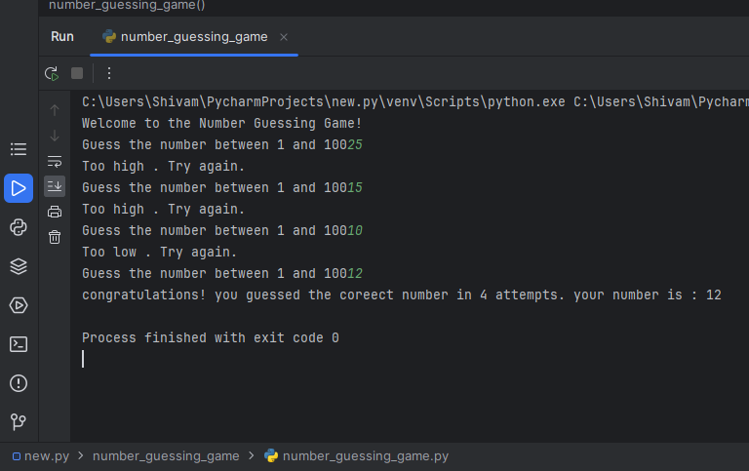

Future Scope for Number Guessing Game:

1. Advanced AI Integration:

- Implement cutting-edge artificial intelligence algorithms to enhance the game's adaptability and intelligence. The AI should learn and adjust its difficulty dynamically based on the player's skill level, ensuring a challenging and engaging experience.

2. Multiplayer and Social Features:

- Introduce multiplayer modes that allow users to compete against friends or other online players in real-time. Incorporate social media integration to share achievements, high scores, and invite friends to join the game.

3 Virtual Reality (VR) Support:

- Explore the integration of virtual reality to provide an immersive gaming experience. Players can step into a virtual environment where they physically interact with the game, making the guessing process more intuitive and entertaining.

4. Customization and Personalization:

- Allow players to customize their gaming experience by choosing themes, backgrounds, and soundtracks. Implement a system to remember and adapt to each player's preferences, creating a personalized and enjoyable atmosphere.

5. Educational Components:

- Introduce educational elements within the game, such as math challenges or trivia related to numbers. This can transform the game into a tool for learning while having fun, making it suitable for a broader audience, including students.

6.Cross-Platform Compatibility:

- Enable players to seamlessly switch between different devices and platforms without losing their progress. Implement cloud-based synchronization to ensure a consistent gaming experience whether playing on a smartphone, tablet, computer, or gaming console.

7.Dynamic Challenges and Quests:

- Integrate a system of dynamic challenges and quests that evolve over time, providing players with new objectives and rewards. This keeps the game fresh and encourages long-term engagement.

8. Blockchain Integration for Rewards:

- Implement a blockchain-based system for in-game rewards and achievements. This not only adds a layer of security to the game but also allows players to trade or showcase their achievements in a decentralized and transparent manner.

9. Live Events and Tournaments:

- Organize live events and tournaments with real-time leaderboards. This encourages friendly competition among players and adds a social and competitive aspect to the game.

10.Continuous Updates and Community Feedback:

- Establish a system for regular updates based on user feedback. Actively engage with the gaming community to gather input on new features, improvements, and bug fixes, ensuring the game evolves to meet the expectations and desires of its player base.

Conclusion :

In conclusion, the Number Guessing Game project offers a personalized and challenging experience with advanced AI. Future plans include VR integration, multiplayer modes, and educational elements. Cross-platform compatibility, blockchain rewards, live events, and community feedback enhance the game's dynamic nature. The project aims to be an innovative force, evolving with user preferences for a captivating gaming experience.